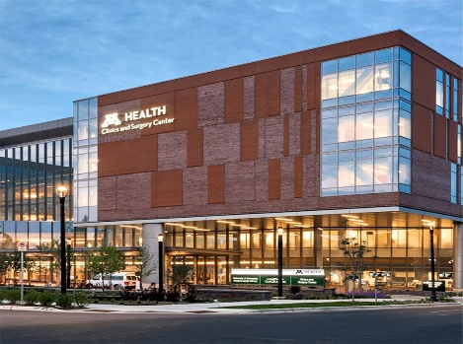

rapid hiring event
Attention! Come join us for our virtual hiring event via Zoom on Tuesday, September 22nd from 11:00 AM – 2:00 PM.
On the spot offers can be made. Starting pay over $15 per hour!
Openings include:

- Housekeeping/ Custodian
- Nutrition Services Aide
- Cook
- Security Officers
- Patient Escort

Our locations include:
- University of Minnesota Medical Center (West & East Bank) – Minneapolis
- Southdale Hospital – Edina
- Ridges Hospital – Burnsville
- St. Joseph’s Hospital – St Paul
- St. John’s Hospital – Maplewood
- Woodwinds Hospital – Woodbury
- Lakes Medical Center – Wyoming
- Northland Medical Center – Princeton

To register for our virtual hiring event contact: amanda.orm@fairview.org

